

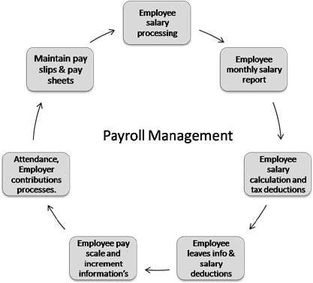

Name : Atharv Srivastava
Class : XII
Roll no.: ________

CERTIFICATE

This is to certify that the project work “Payroll management ” is a bonafide record of work done by Prachita Srivastava under my guidance and supervision.

Ruchika Thukral
DPS Sushant Lok

INDEX

1. | Acknowledgement
2. | Introduction
3. | Code
4. | Output
5. | Bibliography

ACKNOWLEDGEMENT

I would like to express my special thanks of gratitude to my computer science teacher Dr. Ruchika Thukral for her able guidance and support in completing my project.

I would also like to thank my Principal who gave me the golden opportunity to do this project.

INTRODUCTION
A payroll management system is a software that is used to manage all the employee's financial records in a simple and automated fashion.

Our payroll management allows the user to add, delete and modify an employee’s details. It also allows the user to display the payroll of all the employees.

This project uses Python and MySQL to store, process and retrieve information regarding employees and their salaries.

CODE

#importing mysql connector
import mysql.connector
import datetime
from tabulate import tabulate

db=input("Enter name of your database: ")

mydb=mysql.connector.connect(host='localhost',user='root',password='12345')
mycursor=mydb.cursor()
#creating the database
sql='CREATE DATABASE if not exists %s' %(db,)
mycursor.execute(sql)
print('Database successfully created!')
mycursor=mydb.cursor()
mycursor.execute("Use "+db)
TN=input('Enter name of the table to be created: ')

query ="CREATE TABLE IF NOT EXISTS " + TN+ " \
(empno int primary key,\
name varchar(15)not null,\
job varchar(30),\
Basic_Salary int,\
DA float,\
HRA float,\
Gross_Salary float,\
Tax float,\
Net_salary float)"

print('Table '+ TN+' created successfully!')
mycursor.execute(query)

while True:
print('\n\n\n')
print('*'*115)
print('\t\t\t\t\tMAIN MENU')
print('*'*115)
print('\t\t\t1. Adding employee records')
print('\t\t\t2. Displaying record of all employees')
print('\t\t\t3. Displaying record of a particular employee')
print('\t\t\t4. Deleting record of all employees')
print('\t\t\t5. Deleting record of a particular employee ')
print('\t\t\t6. Modification in a record')
print('\t\t\t7. Displaying payroll')
print('\t\t\t8. Displaying salary slip for all employees')
print('\t\t\t9. Displaying salary slip for a particular employee')
print('\t\t\t10. Exit')

choice=int(input("Enter your choice: "))

if choice==1:
try:
print('Enter employee information...')
empno=int(input('Enter employee number: '))
name=input('Enter name: ')
job=input('Enter job: ')
basic=float(input('Enter basic salary: '))

if job.upper()=='OFFICER':
da=basic*0.5
hra=basic*0.35
tax=basic*0.2
elif job.upper()=='MANAGER':
da=basic*0.45
hra=basic*0.30
tax=basic*0.15
else:
da=basic*0.40
hra=basic*0.25
tax=basic*0.1

gross=basic+da+hra
net=gross-tax
rec=(empno, name, job, basic, da, hra, gross, tax, net)
query='insert into '+TN+' values (%s,%s,%s,%s,%s,%s,%s,%s,%s)'
mycursor.execute(query,rec)
mydb.commit()
print('Record added successfully!')

except:
print('Something went wrong')

elif choice==2:
try:
query='select * from '+TN
mycursor.execute(query)
print(tabulate(mycursor, headers=['EmpNo', 'Name', 'Job', 'Basic Salary', 'DA', 'HRA', 'Gross Salary', 'Tax', 'Net Salary'], tablefmt='psql'))

except:
print('Something went wrong')

elif choice==3:
try:
en=input('Enter employee no. of the record to be displayed…')
query='select * from '+TN+' where empno= '+en
print(query)
mycursor.execute(query)
myrecord=mycursor.fetchone()
print('\n\nRecord of Employee No.:'+en)
print(myrecord)
c=mycursor.rowcount
if c==-1:
print('Nothing to display')

except:
print('Something went wrong')

elif choice==4:
try:
ch=input('Do you want to delete all the records? (y/n)')
if ch.upper()=='Y':
mycursor.execute('delete from '+TN)
mydb.commit()
print('All the records are deleted...')

except:
print('Something went wrong')

elif choice==5:
try:
en=input('Enter employee no. of the record to be deleted…')
query='delete from '+TN+' where empno= '+en
mycursor.execute(query)
mydb.commit()
c=mycursor.rowcount

if c>0:
print('Deletion done')

else:
print('Employee no. ',en,' not found')

except:
print('Something went wrong')

elif choice==6:
try:
en=input('Enter employee no. of the record to be modified...')
query='select * from '+TN+' where empno= '+en
mycursor.execute(query)
myrecord=mycursor.fetchone()
c=mycursor.rowcount

if c==-1:
print('Empno '+en+' does not exist')

else:
name=myrecord[1]
job=myrecord[2]
basic=myrecord[3]
print('empno : ',myrecord[0])
print('name : ',myrecord[1])
print('job : ',myrecord[2])
print('basic : ',myrecord[3])
print('da : ',myrecord[4])
print('hra : ',myrecord[5])
print('gross : ',myrecord[6])
print('tax : ',myrecord[7])
print('net : ',myrecord[8])
print('-------------------------')
print('Type value to modify below or just press the
Enter key for no change')

x=input("Enter name: ")

if len(x)>0:
name=x
x=input ('Enter job: ')

if len(x)>0:
job=x
x=input ("Enter basic salary")

if len(x)>0:
basic=float(x)
query='update '+TN+' set name= '+" ' "+name+" ' "+' , '+' job= '+" ' "+job+" ' "+' , '+ ' basic_salary= '
+str(basic)+' where empno= '+en

print(query)
mycursor.execute(query)
mydb.commit()
print('Record modified')

except:
print('Something went wrong!')

elif choice==7:
try:
query='select * from '+ TN
mycursor.execute(query)
myrecords=mycursor.fetchall()
print("\n")
print(60*' * ')
print("Employee Payroll".center(90))
print(60*" * ")
now =datetime.datetime.now()
print("Current Date and Time: ",end=" ")
print(now.strftime("%Y-%m-%d %H:%M:%S"))
print()
print(60*" - ")
print('%-5s %-15s %-10s %-8s %-8s %-8s %-9s %-8s %-9s' %('Empno','Name','Job','Basic','DA','HRA','Gross','Tax',' Net '))
print(60*'-')

for rec in myrecords:
print('%4d %-15s %-10s %8.2f %8.2f %8.2f %9.2f %8.2f %9.2f'%rec)
print(95*"-")
print()
print('Record modified')

except:
print('Something went wrong')

elif choice==8:
try:
query='select * from '+TN
mycursor.execute(query)
now=datetime.datetime.now()
print("\n")
print("-"*115)
print("\t\t\t\tSalary Slip")
print("-"*115)
print("Current date and Time: ",end=" " )
print(now.strftime("%Y-%m-%d %H:%M:%S"))
myrecords=mycursor.fetchall()
print('Empno.\t', 'Name\t', 'Job\t', 'Basic Salary\t', 'DA\t ', 'HRA\t', 'Gross Salary\t', 'Tax\t', 'Net Salary\t ')

for rec in myrecords:
print('%4d %-15s %-10s %8.2f %8.2f %8.2f %9.2f %8.2f\t %9.2f'%rec)

except :
print("Something went wrong")

elif choice==9:
try:
en=input("Enter employee number whose pay slip you want to retrieve: ")
query='select * from '+TN+ ' where empno= '+en
mycursor.execute(query)
now=datetime.datetime.now()
print("\n\n\n\t\t\t\tSALARY SLIP: ")
print("Current Date and Time: ",end=' ')
print(now.strftime("%Y-%m-%d %H:%M:%S"))
print(query)
print(tabulate(mycursor, headers=["EmpNo.","Name","Job","Basic Salary","DA","HRA","Gross Salary","Tax","Net Salary"],tablefmt="psql"))

except Exception as e:
print("Something went wrong",e)

elif choice==10:
print("Exiting Database")
break

else:
print("Wrong choice...")

OUTPUT
Creating Database:
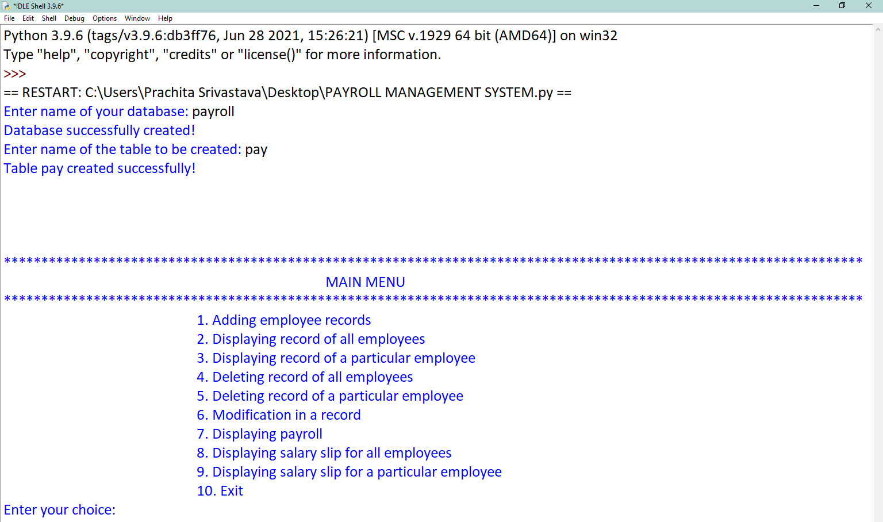

TABLE 1:
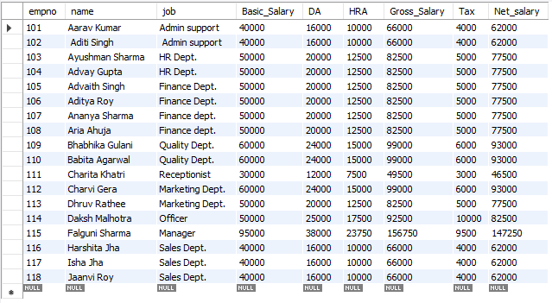
CHOICE ==1
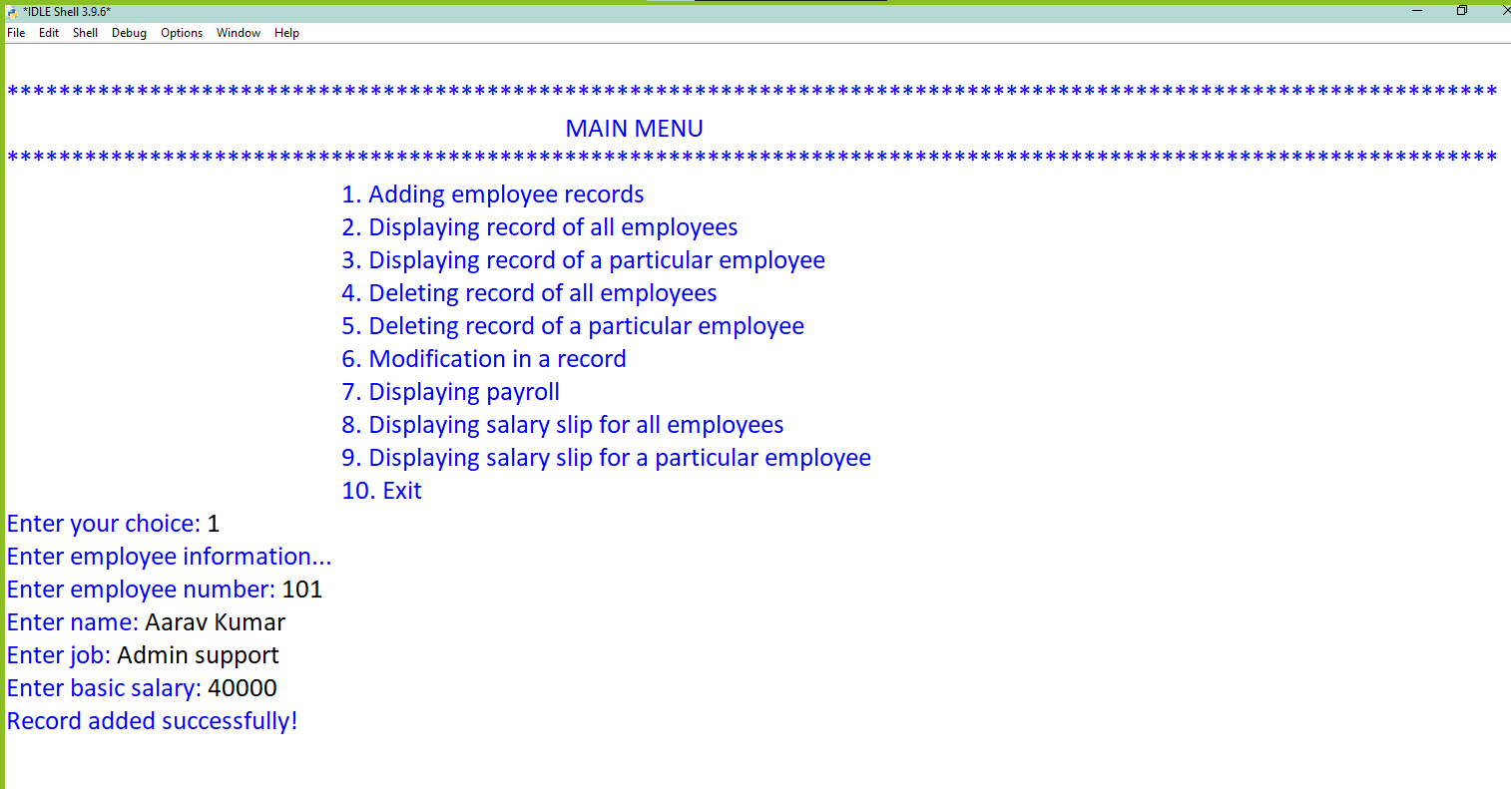

CHOICE ==2

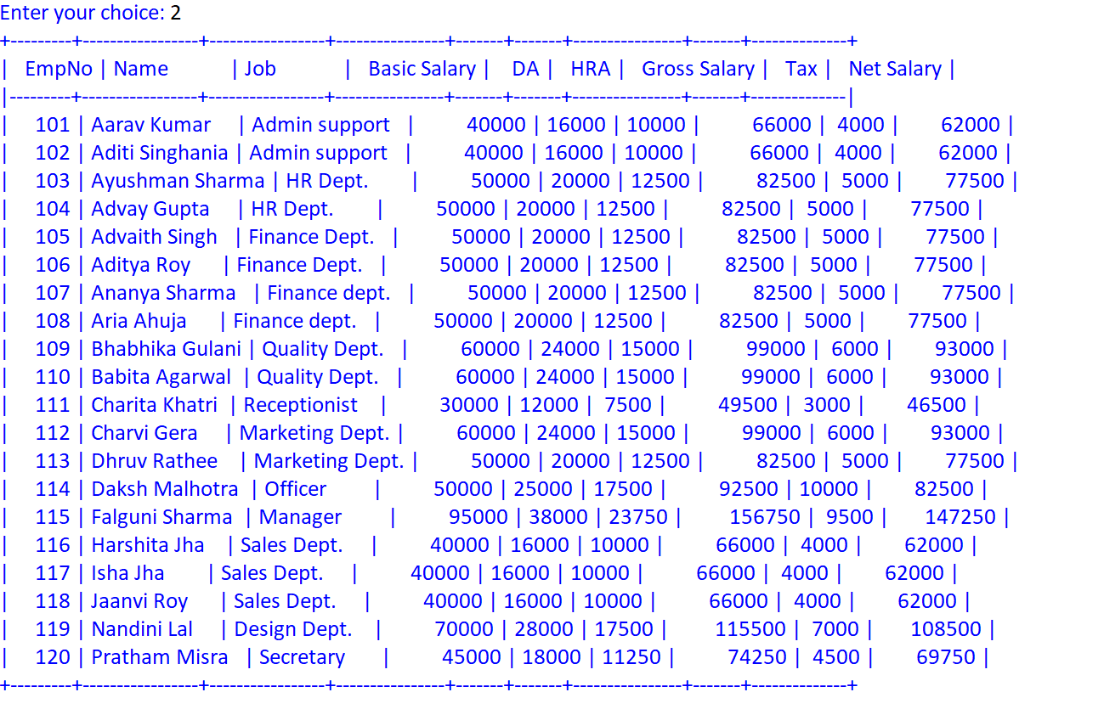

CHOICE ==3

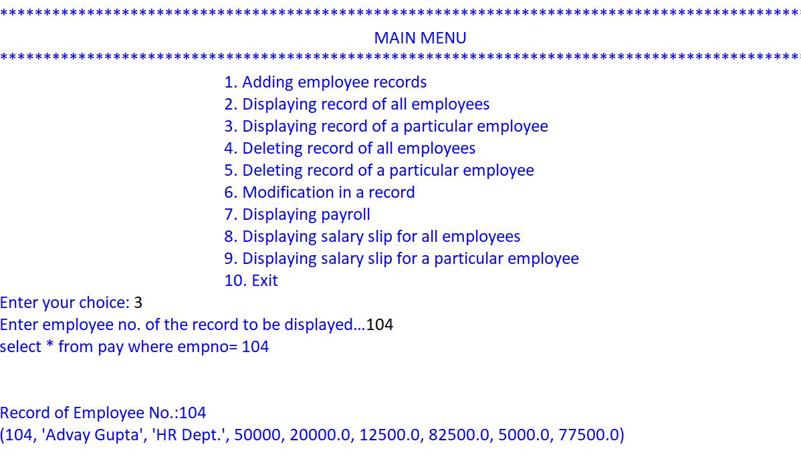

(CHOICE 4 IS AFTER CHOICE 9)
CHOICE==5

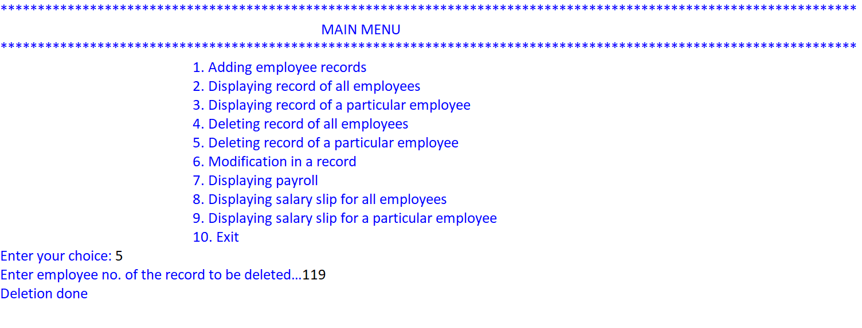

CHOICE==6

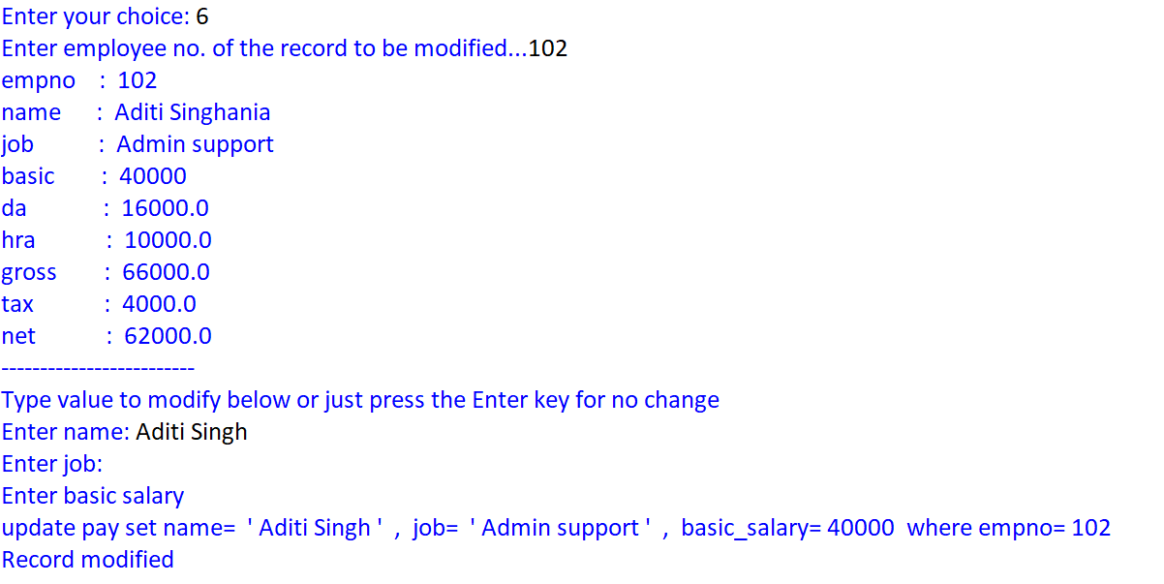

CHOICE==7

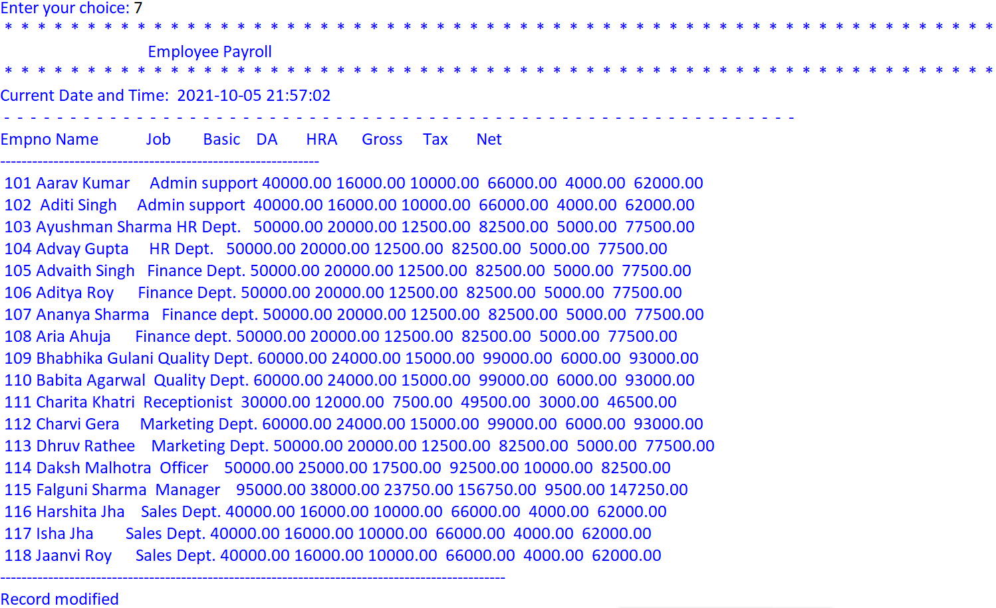

CHOICE ==8

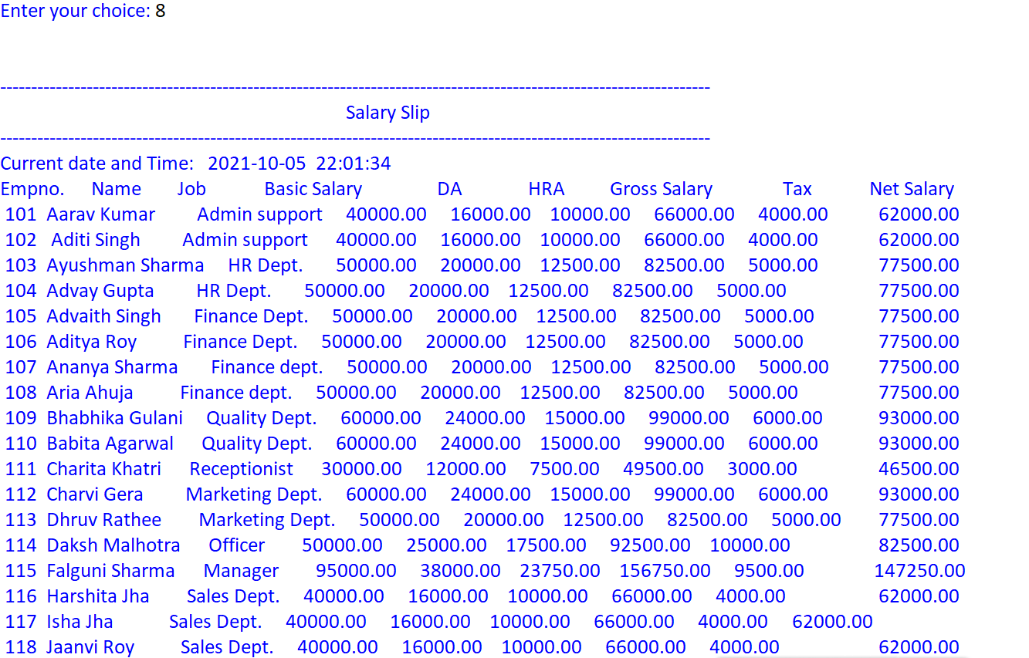

CHOICE==9

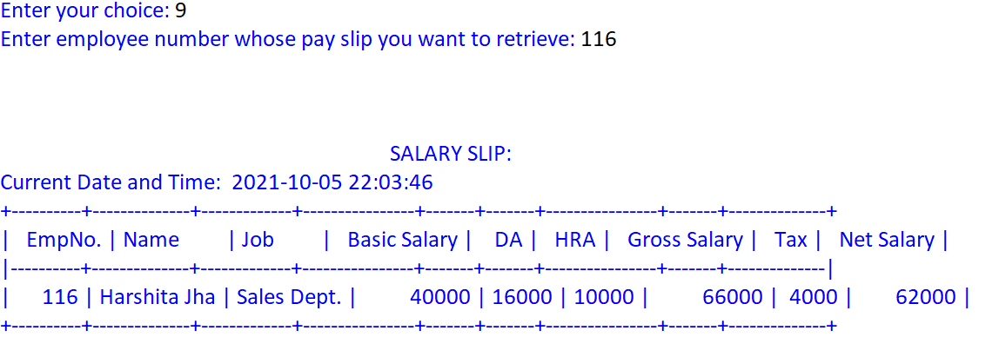

CHOICE==4

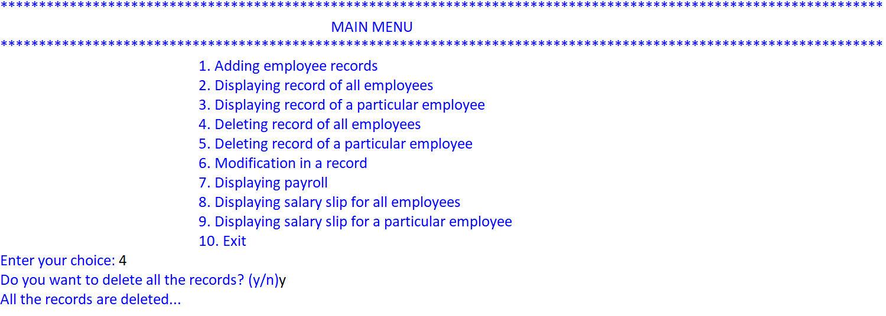

CHOICE==10
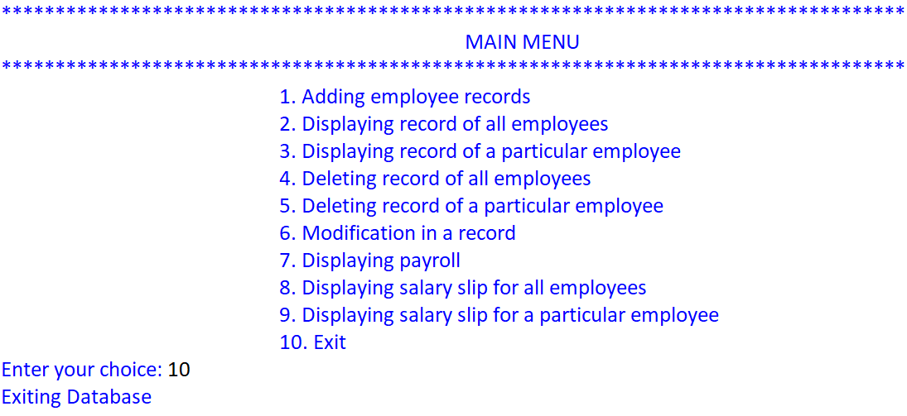

BIBLIOGRAPHY

- Computer science with Python by Sumita Arora
- W3schools.com
- Geeksforgeeks.com

